## How to Download and Run SEV Tool

Version: v3

Updated: 2018-11-26

Contents

How to Download and Run SEV Tool 1

OS Requirements: 2

Downloading the SEV Tool 2

1. Installation Steps 2

2. For everyone without access to Internal GIT 2

3. Compile the driver 2

Run the SEV Tool 2

Debugging the SEV Tool 3

# OS Requirements:

When using Ubuntu, you must have Ubuntu 18.10 or later to have the latest kernel headers and libc. If you try to use an older kernel and use ukuu to update the kernel manually, this will give you the newest kernel headers, but you will have an old version of libc, which processed the older kernel headers, not the original ones. It’s (probably) possible to update libc and have it process the new kernel headers, but it’s a lot of work.

# Downloading the SEV Tool

These instructions assume you are running a normal Linux kernel. The SEV Tool has only been officially tested on 18.10

## 1. Installation Steps

1. Boot into the default, non-SEV Ubuntu kernel.  
   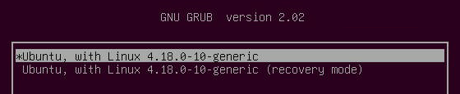
2. Install git, make, gcc, g++ and dependencies

#sudo apt install git make gcc g++ -y --allow-unauthenticated

## 2. For everyone without access to Internal GIT

Github is located at: <https://github.com/AMDESE/sev-tool>

## 3. Compile the driver

This needs to be done for each kernel you want to test with. Running the build script does the following things:

* Downloads, configs, and builds the OpenSSL Git code (submodule init/update)
* Cleans and builds the SEV Tool

#cd sev-tool

#sh ./build.sh

# Run the SEV Tool

1. Pull latest changes from Git for any new added/modified tests

#cd sev-tool

#git pull

#sh ./build.sh

1. Run suite:

#cd src

#sudo ./sevtool

The tool will provide you with instructions on input parameters, etc

## Debugging the SEV Tool

kdbg makes it very easy to step through, add breakpoints to, and debug the test suite

#sudo apt-get install kdbg

Note: kdbg seems to have some issues with Ubuntu 18.04/18.10, but works fine on Ubuntu 16.04